ƒ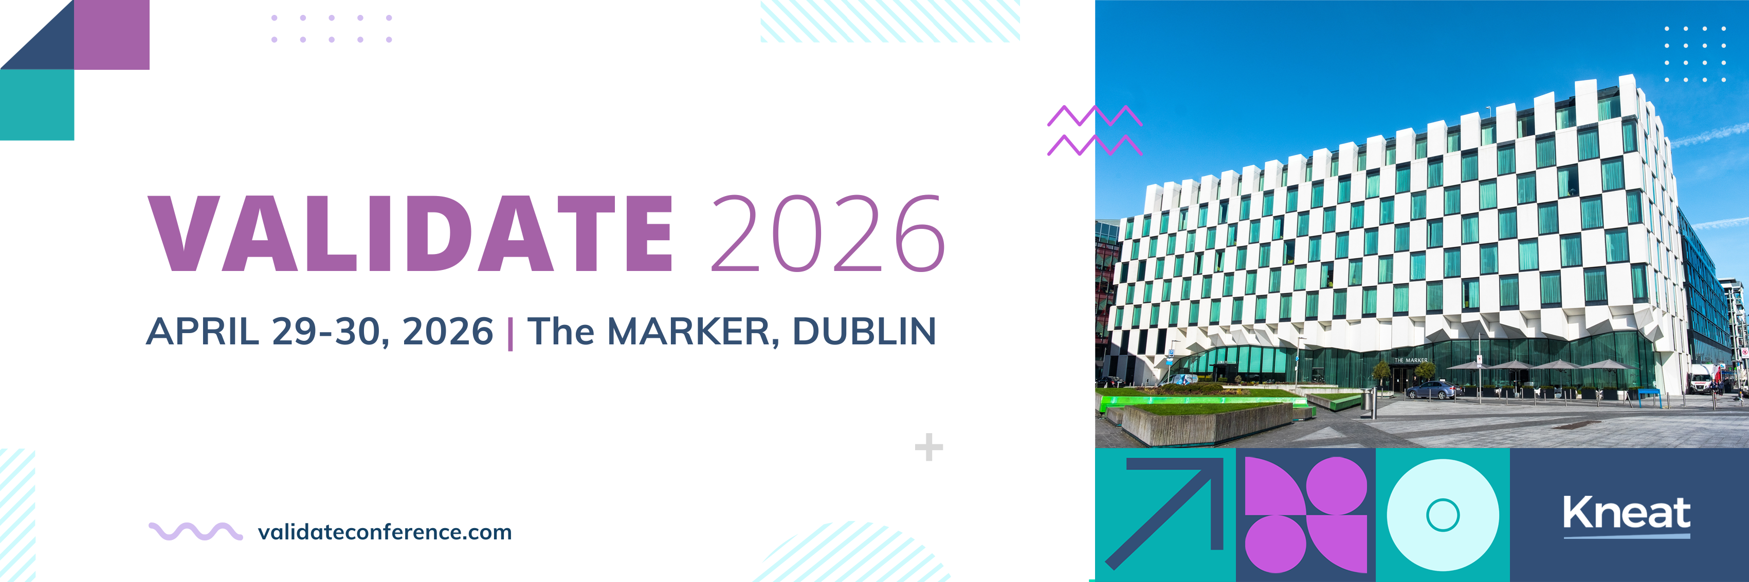

**[Date]**  
  
Dear [Manager],  
  
I would like your approval to attend this two-day, multi-track, intensive educational and training conference specifically designed for validation and quality professionals working in highly regulated industries.

**VALIDATE 2026**

VALIDATE 2026 brings together senior Quality Executives, Validation Engineers, Specialists, and Managers, QA and Validation Technologists, and Regulatory Experts with Life Sciences industry influential leaders to connect, collaborate, discover and apply validation trends, technologies, regulations, and best practices.

The conference is the premier event for tech-forward validation and quality professionals. The [conference schedule](https://www.validateconference.com/schedule/) features many [expert speakers](https://www.validateconference.com/speakers/), including industry leaders in Pharma, Biotech, Medical Device, Consumer Health, CMOs and more. Past customer speakers include J&J, Eli Lilly & Co, GSK, MSD & Co., Sanofi, Thermo Fisher, Alcon, and more.

**The agenda includes:**

* A private customer-only networking reception before the conference begins
* Exclusive customer sessions, including product vision and product road map and Kneat Gx functionality training on new releases
* Multiple expert-led conference sessions with insights into validation, technology, and best practices including topics on:
  + Digital Maturity & Pharma 4.0
  + Validation 4.0
  + Innovation Award Presentations From Customers
  + Implementing Process Performance Qualification
  + Holistic Control Strategy
  + AI in Validation
  + Digital Validation & Computer Software Assurance: Meeting CSV Demand in the Transition to 4.0
  + Accelerating Adoption: Strategies and Tactics
  + Data Integrity & Quality
* Networking opportunities with like-minded peers at sessions, dinners, and offsite social experiences

**By attending I will gain:**

* Processes and tools that will aid best-practice validation management
* Digital validation software training from industry professionals who support life sciences world leaders
* Increased productivity and time-saving measures
* Insights into smarter use of our resources (people, processes, and technologies)
* Opportunity to establish connections in validation for future advice and best practices on Kneat and validation
* Help to implement effective strategies to align my role and the business needs

The event is organized by [Kneat](https://kneat.com/) — they understand the role, the challenges, and the skills required to be a successful validation professional, and I believe that the content at the conference will positively support my role, provide me with the latest technological tools, knowledge, and connections that will help me to achieve more efficiencies for our organization.

**Here are the details:**

* Event Name: VALIDATE 2026
* Date: April 29-30 –, 2026
* Location: Marker Hotel, Dublin IE
* [Registration fee](https://www.validateconference.com/tickets/): €349 +VAT * with discount code EarlyBird2026

Best regards,

[NAME, TITLE]

*Early-bird pricing, discounted from $£649 +VAT with Customer Discount Code. **Get your tickets before January 31, 2026 to secure this price.**